

**Friday 22nd October**

**Dear Parents,**

Now that I am a few weeks on from the London Marathon and my legs have recovered, I wanted to write a little something to thank each and every one of you for your generosity.

I took on the biggest and most difficult challenge of my life but the day was amazing and worth every second. The overwhelming feeling as I crossed the finish line was one that I will never forget and knowing that I was raising money for such a brilliant cause pushed me to the end. Mile 22 was a very tough one but I managed to do it and am now feeling extremely proud of myself.

Once again, a massive thank you for all of your support and for playing such a large part in the huge amount of money I raised; an astonishing £7,351! I was absolutely stunned to raise such an incredible amount of money.

I always said I would only run in a marathon once, but never say never!

**Miss A O’Sullivan**

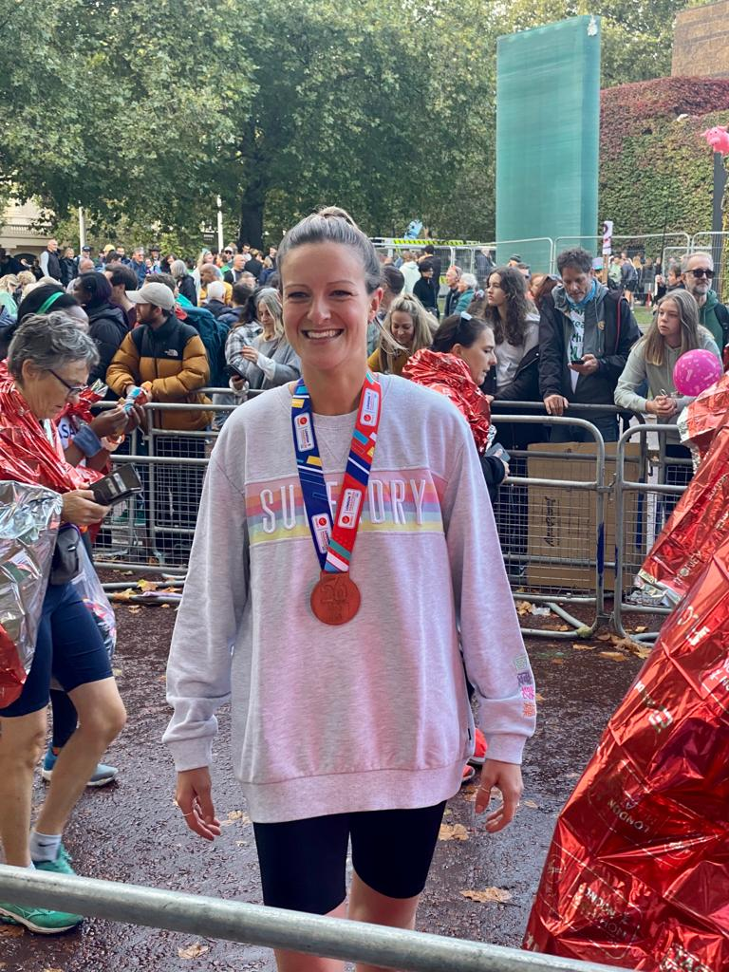

**PTA EVENTS**

The PTA have arranged a **Christmas Wreath Making** event for parents on Thursday 9th December at 7.00pm. A flyer and booking details will be sent out shortly.

The **Christmas Fair** will be held in school on Saturday 27th November 1.00 – 4.00pm. I know plans are well underway and a lot of work has already gone into devising new ways of making this a fun and enjoyable afternoon for the whole school community. Please support the committee in any way you can; the money raised benefits all the pupils throughout the year in a number of ways. Thank you, PTA!



**HARVEST FESTIVAL**

Thanks to your generosity, Year 6 were kept extremely busy sorting and packing the harvest gifts brought into school. Mrs Sowter took a car loaded with provisions to ‘Living Well’ foodbank and lunch club in Penge. Major Emma Spencer from New Addington Salvation Army came to school and collected the other half of our donations, including the items of clothing. We know the difference your gifts will make to families in our local area. Thank you.



**PROJECT WATERAID**



In preparation for leading the Harvest Assembly for the whole school, a group of Year 6 pupils researched the charity ‘WaterAid’, a charity we have supported before. The children (and staff) find it incomprehensible that there are still places in our world where people have no access to fresh water or a working toilet. In response to their findings, we would like to see if together we can raise some money for this charity. Each pupil will be given a bottle of water to drink and, as they do so imagine what it would be like to have no clean water to enjoy. If they are able, with your help and support, we would love them to refill their bottle with any spare change you or your friends and relations may be willing to spare.

Please don’t think the bottle has to be full. We are conscious that during the past months we possibly have not been using cash as much as we used to and therefore might be light on coins! One powerful message for the children is that by each of us bringing in a little, we can actually end up with a decent sum of money when it is all totalled up together.

**The bottles should be brought back to school on the first Monday after half-term when they will be emptied and recycled.**

**COMING UP:**

Friday 5th November: ISA Football Tournament

Monday 8th November: School resumes

Tuesday 9th November: Year 2 trip to Al-Emaan Centre

Friday 12th November: PTA Own Clothes Day (Jolly Jar/ Chocolate donations)

Thursday 18th November: Re-scheduled ‘Scootsure’ session for Year 2 (in school)

Thursday 18th November: Parent/Teacher Interview Evening and e-safety talk – 4.00 – 8.00pm

Friday 19th November: Year 1 trip to National Gallery

Saturday 20th November: Bromley Schools Cross-Country event @ Crystal Palace (Year 5 and 6)

Monday 22nd November: St David’s Dash Cross-Country event in school (Year 3 and 4)

Saturday 27th November: PTA Christmas Fair – 1.00 – 4.00pm

Friday 3rd December: Parents Voice Open Meeting – 8.45am

Tuesday 7th December @ 9.30am – Pre-Reception and Reception Nativity

Wednesday 8th December @ 2.00pm – Pre-Reception and Reception Nativity

Thursday 9th December: PTA Christmas Wreath Workshop @ 7.00pm

Friday 10th December: Prep Carol Service @ St John’s Church – 6.30pm

Tuesday 14th December @ 2.00pm – Years 1 and 2 Nativity

Wednesday 15th December @ 9.30am – Years 1 and 2 Nativity

Thursday 16th December: Christmas Lunch and Christmas Jumper Day

**FRIDAY 17th DECEMBER: TERM ENDS at 12.00pm for all pupils**

**RAINBOW CLUB**

**Monday 20th and Tuesday 21st December**

**SPRING TERM begins Wednesday 5th January**

**FUTURE HOLIDAY DATES**

The term and holiday dates for 2022/2023 have now been agreed and posted on the school website.

Please note that an extra Bank Holiday has been granted next May/June to commemorate the Queen’s Platinum Jubilee. The official BH dates are Thursday 2nd and Friday 3rd June, both of which are during our half- term break. We are therefore adding Friday 27th May as an additional holiday day to recompense staff and give our families a chance to enjoy a longer break.

**SPECIAL AWARDS**

|  |  |  |
| --- | --- | --- |
| **Rohan P** | **Reception (Hedgehogs)** | **Fantastic behaviour and outstanding effort all half term** |
| **Meadow B** | **Reception (Squirrels)** | **For settling in so fantastically to Reception and always being kind** |
| **Nico R** | **Year 1 (Badgers)** | **Polite, hardworking and always gives of his best** |
| **Tuyanji F** | **Year 1 (Rabbits)** | **Great all-round effort at all timeS** |
| **Aoife O’H** | **Year 2 (Owls)** | **Great attitude and work ethic** |
| **Felix C** | **Year 3 (Elm)** | **For persevering and remaining focused in class** |
| **Holly H** | **Year 4 (Acer)** | **For always being kind and using initiative when being helpful** |
| **Evan Mc L** | **Year 5** | **For his effort and attitude to Year 5, including his self-motivation and determination** |
| **Esha R** | **Year 5** | **For her all-round contribution to all aspects of her learning in Year 5, including her curiosity and independence** |
| **Rayanna L** | **Year 6** | **For her maturity and kindness shown to other class members** |

**HEAD TEACHER AWARDS**

|  |  |
| --- | --- |
|  |  |
| Alex B | Year 1 |
| Hannah M | Year 1 |
| Samuel S | Year 1 |
| Aaron D | Year 1 |
| Alexander F-F | Year 1 |
| Kai H | Year 1 |
|  |  |
| Darcey D | Year 2 |
|  |  |
| Emily R | Year 3 |
| Niama T | Year 3 |
|  |  |
| Mia J | Year 4 |
| Victoria L | Year 4 |
| Rory T | Year 4 |
|  |  |
| Florence I | Year 5 |
| James McG (3) | Year 5 |
| Thor M-B | Year 5 |
| Kairav P | Year 5 |
| Srisakthi K | Year 5 |
| Megan McG | Year 5 |
|  |  |
| Sebastian A | Year 6 |
| Mya B | Year 6 |
| Florence K | Year 6 |
|  |  |

**YOUNG VOICES CHOIR**

Rehearsals are going well for our choir. The schedule for the rest of this term is as follows:

|  |  |
| --- | --- |
| **TUESDAYS – 7.45am** | **WEDNESDAYS – 7.45am** |
| 9th November | **17th November** |
| 23rd November | **1st December** |
| 7th December |  |
| **STOP PRESS! MRS SOWTER WILL HAVE AN EXTRA REHEARSAL ON A THURSDAY MORNING AT 7.45AM** | |

**SMART MOVERS INITIATIVE**

Well done to all those pupils who have, supported by parents, changed the way they have been travelling to school. Encouraged by our Year 6 Junior Travel Ambassadors, Harry C and Kayla O, 46 children throughout the school recorded using public transport, walking, cycling or scooting to school on at least 10 occasions during October and have now received their badges. I wonder if we can get even more joining in next month?

**MRS FOULGER WRITES**

**It’s been a busy and successful half-term with so much to be thankful for and it has certainly been good to have had sports fixtures, a number of trips and ‘in house’ themed events. The staff have been amazing, often battling through with every last reserve of energy, as have the children. Therefore, I hope everyone manages to take some time out to rest, relax and recharge before our return in November when, no doubt, we will be regaled with Christmas songs on a daily basis – I can’t wait!**

**Enjoy the break and keep well – race you to the sun-lounger…**

**Best wishes,**

**Julia Foulger**